SUBJECT: [Company Name] Launches new User Adoption Service

We’ve engaged with our learning partner Fivel Systems to provide specialized User Adoption training. They’re highly regarded in the technology community for their expertise in the science of learning, human behavior and user adoption. This enables us to offer a unique technology adoption service for our customers who often need help onboarding their end-users.

Starting this week, we’ll be launching Fivel’s service internally. This will give you the opportunity to experience the service directly to help understand the What, Why & How. With this experience, you’ll be able to better explain the service & benefits to our customers.

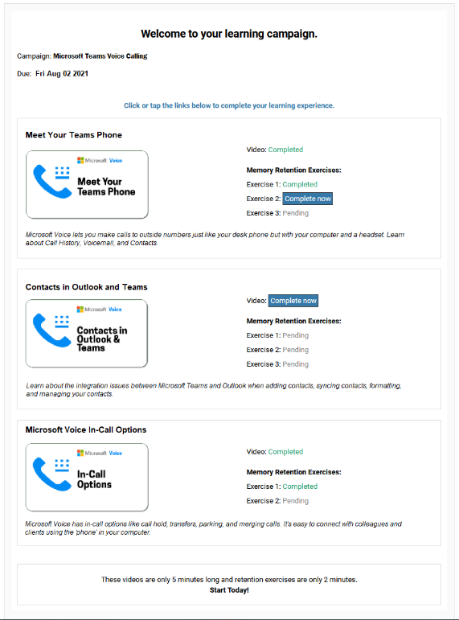
What will you experience?
- You will receive an email from Fivel with hyperlinks to 5 short videos (5-minutes each), similar to this one on how to use Microsoft Voice.
- Click on the Complete Now link to begin the training. No login credentials are required.
- This will launch the Fivel player and you can begin your training. Click ‘play’ if the video doesn’t auto-play.
- A short, multiple-choice retention quiz will follow at the end of each video, this is considered the first Exercise.
- You can watch the next video in the series either by clicking on the Next Up video that appears right after the quiz, by clicking on My Learning Path in the upper left corner of the screen, or by navigating back to the original email and selecting Complete Now.
- A couple of days after completing each video and quiz, you will receive an email to complete the retention exercises for that learning moment.
- You’ll receive reminder emails to encourage you to complete all the videos and exercises.
- A learning series is called a Campaign and it might have a completion date. Please finish your learning journey before the completion date.

What are the benefits of the training?
- Increase your proficiency. Learn how to use the software to your advantage.
- Remember more. Sequenced retention exercises reinforce the learning.
- Less frustration. Change is inconvenient. This system will help you to adapt quickly and easily.
- Memory refresh. All videos are accessible anytime on your desktop or Fivel’s GetIT mobile application.

Here’s a link to a short article about the scientific reasons why people struggle to adopt new technologies. We think you’ll find this interesting and useful when discussing User Adoption with customers.
http://fivel.ca/why-employees-resist-change/

