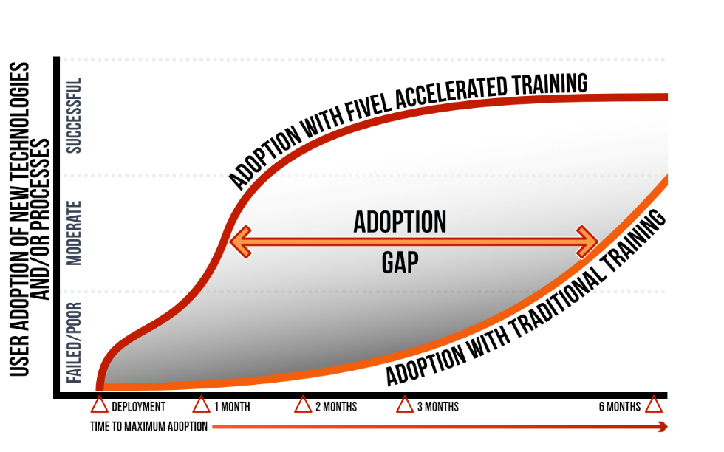
The Secrets Behind Why Employees Resist Change

Many of today's business articles repeatedly tell us that change is happening at an ever-increasing speed. Innovation, a key driver of change, is an essential requirement for any business to stay competitive. Not surprisingly, CEO’s proclaim that their most important role is to invoke change in their organization.
We are also reminded that the rate of technology change is accelerating. In the past, technology companies would release new software once every year or two. Cloud-based computing has altered that pattern to months or even weeks. As Application Development shops shift to a rapid development technique called Agile they are releasing new software features more frequently.
How are these changes affecting employees? From their perspective it is overwhelming. If you add up the number of times we ask employees to learn a new skill it can add almost 30 requests in a year. People who create the change don’t often realize how many other demands are being made on employees. I liken this to an iceberg. We see the big projects above the water but don’t realize the volume of changes and peril under the water. Captain EJ Smith, of Titanic fame, found out the hard way! Some companies, recognizing the volume of demands, have even created a new role of Change Coordinator to gate or regulate the level of disruption to employees.
How do employees experience a change? When we upgrade / replace a person’s technology or process, we are asking them to give up something they’ve learned to master. Effectively, they now move from a state of competency to a state of incompetence. Remember the last time you replaced your smartphone? Basic functions that were easy are now difficult. Anxiety and frustration set in and can last for weeks or months until you return to a level of competency again.
We think we are making it easier for employees by doing fundamental training, or worse, asking them to find the information on a company knowledge portal. With the complexity and time pressures of managing a change project, it is easy to “expect” employees to adapt rather than “provide them with enough support” during their “loss of competency”. Pressure to complete a project can sometimes leave users on their own to discover how to navigate new systems.
People come to work each day with the hope of accomplishment. It creates an intrinsic motivational reward that dwarfs the impact of a good salary. The workplace generates enough disruption and interruptions even on a good day. A constant cycle of relearning tools or processes can make it difficult for an employee to focus on and complete their core accomplishments.
When we master a learned task we use a brain subroutine (unconscious habit) so we don't have to "think" so hard. It actual relates to the body’s need to reduce calorie consumption. Give a person a new tool and their brain suffers a temporary period of incompetency. Recovery (building new unconscious habits) can take weeks or even months, depending on the complexity of the “new thing”. Remember your smartphone experience?
This cycle of competency and incompetency is happening on a regular basis for employees (new phone, new application, new printer, new process). This is the underlying root of most change resistance that goes beyond visible factors (top of the iceberg) like job insecurity and the other factors we often reference.
Our advisory team at Fivel includes a cognitive brain therapist and a few psychologists combined with a large body of studies and research. What we came to conclude is that corporate learning and change management have not adapted well to the faster rate of change. Our goal is to take this scientific knowledge, along with our understanding of the problem and combine it with our innovations to produce a solution that benefits employees, the company and the Change Team.
What are some of those innovations?
First, we need to offset a retention problem called Memory Decay, a well-documented fact that people forget 80% of what they learn within 2 weeks. Engaging a person in a series of recall quizzes spaced out over 4 weeks has a dramatic change in outcome.
Second, structuring delivery of the content into 5-minute micro Learning Moments improves participation as it recognizes our busy schedules. In today’s environment, people get interrupted much more frequently so it becomes difficult for them to sit through any lesson that is longer than 10 minutes.
Third, learning needs to be approached in a programmatic way and coordinated. Making information available on a self-serve portal doesn’t work because most people don’t access these services without prompting.
Lastly, we need to go beyond the learning step to determine if people are actually using the new tool or process. By tracking usage transaction counts you can determine that a person has moved from the knowledge transfer stage to actual engagement. When an insurance company wanted to improve their claims processing they asked their agents to leverage Skype for Business. Without knowing if agents were engaging they hindered their success and waited much longer for the business value to occur.
Integrating the elements of brain biology, behavioral science and intrinsic motivation into a change management project will produce faster, better results and bigger wins for the project team. Find out how you too can reduce the impact of the incompetency cycle in your organization and produce increased success. Investing in a solution is good. Investing in your employees is much smarter.

