Fresh Thinking About IT & Change Management

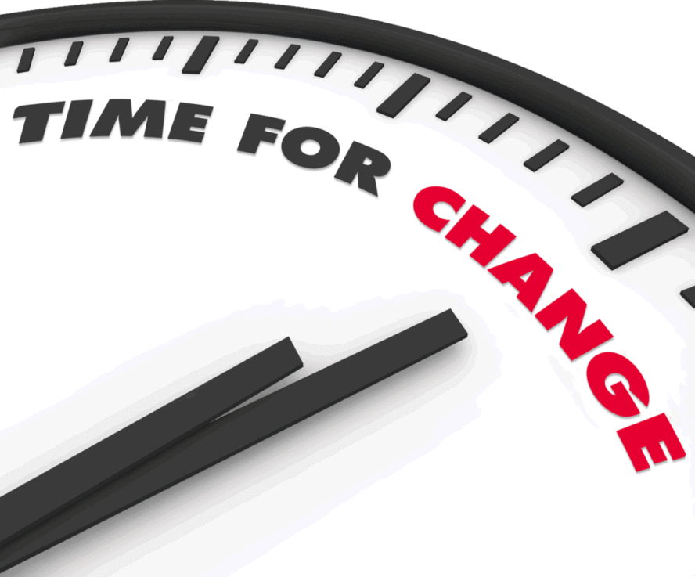
IT organizations have been hardwired from past experience to think in terms of a project paradigm. We prepare, we deploy, we complete, we move on.
Agile development and cloud computing are distorting that model as application vendors release new features multiple times per year. Customers once chose their deployment dates but Cloud computing has transferred that control to vendors. Software releases now show up continuously and unexpectedly.
The application vendors I speak with are impacted as well. They find that users are not engaging with their new and improved product features. For example, one vendor released a new feature only to find 22% of the expected users were utilizing it. If you think that this is an isolated case, think again.
In truth, utilization (or adoption) is a common problem for many vendors and customers. It is often a low priority due to the number of other projects on the go and the need for project teams to move on to other tasks.
Yes, many companies have a portal where users can learn on their own, however, numerous behavioral studies show that only 10-15% of any group are motivated to self-learn. So, the question becomes what are we doing to manage the other 85%?
If you don’t innovate the adoption process, digital innovation on its own will not succeed as expected. The new paradigm means a “project” never ends, it just transitions into a continuous refresh cycle. Flash updates, engagement tracking, and participation rewards must be part of the new model.
Project success requires that we adapt how we deploy resources or, alternatively how we add agile adoption services into the mix. Digital Adoption and Change Management are about changing business outcomes. With one less hurdle, the outcome gets a little closer.

