Digital Transformation: What We Miss

Digital transformation is the latest holy grail of organizational change. Change is not new but unlike past changes, there is a key difference; In the past, projects would automate familiar workflows with some level of process enhancement. Employees affected by those changes had to learn a new system with a minor adjustment to the way they worked.

Digital transformation adds another level of challenge for employees. Their comfort zone is attacked. Workflows and job routines are not just altered but in many cases disrupted. Large data sets along with artificial intelligence (AI) can radically change existing workflows and roles for employees.

Organization change has a history of problematic outcomes. A recent article in HBR (Thomas D Davenport) identified companies such as GE, Ford, P&G, and others where the CEO’s were asked to leave in part due to digital transformation projects that were not going well.

An anecdotal high failure rate associated to change management projects is not an accurate reflection of reality. While some initiatives may be a lesson-learned in poor fit, the bulk of initiatives do work, just not to our expectations.

Those disappointments often fall into two categories:
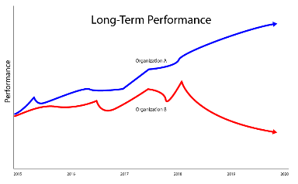
- The expected KPI’s occurred 6 to 24
months later than the projected date
(rolling into next fiscal); or
- The targeted KPI fell short by 30% or
more, collapsing the ROI justification.

What is it that we miss?
Workflow designs and their underlying systems are logical – people are not. Project and change management processes are based on a logical premise that actions lead to reactions. Engaging, rational messages to employees assume that conscious awareness leads to behavioral change.

Anyone who has tried to change his or her eating habits to lose weight will know how wrong the above assumption is. Your unconscious brain will consume half of a bowl of ice cream before your conscious brain reminds you about the new “NO Ice Cream” rule.

So how do employees learn to change? The real question is, “How does the brain change”. Habits are an ancient part of our brain biology designed to help early humans survive. Habits (more appropriately –brain functionality) developed to:

- Reduce calorie consumption (there wasn’t a grocery store on every river bend, so food was sparse)
- Improve our reaction time to everyday threats (when a lion was sighted, there was no time to think – JUST RUN!)

Habits in the workplace help us work efficiently and enable us to focus on meaningful parts of our job. They allow us to focus on the important parts of our job. For example, closing a sale or solving a customer problem will be motivating for employees (providing a dopamine rush – another brain function not to be overlooked). A system or workflow change can stimulate an unconscious resistance in the brain and de-focus our attention away from those more meaningful responsibilities.

Change projects always emphasize good strategy, planning, communications, and deployment, but for some reason undervalue the part where we help each employee adjust their habits. We call it training: “Training never works so why should we spend much money on it?” But we need to think of learning as "habit reforming," and not just "information dissemination." You can buy as much automation and software as you want, but without an investment in smarter learning strategies, the failure rate increases. Can you image buying a car without wheels? You know there will be trouble before you get off the car lot.

You don’t have to be a brain scientist (let us do that for you) to recount the number of software, sales training, or process re-engineering projects that have struggled because of poor user engagement. In fact, many software vendors expect a 15-30% user adoption 9 months after deployment. Imagine purchasing a tank of gas/petrol where over half leaked out. How fast would you fix it?

Another common scenario occurs when employees try to use a new system the old way. In one case, pensioners received extra payments because claims agents entered data like they were using the last system. The organization had to revert back to the old system and relaunch 7 months later.

What is the Solution?
Digital Transformation is complex and has lots of moving parts. The weakest link is employee engagement (adoption). Every project leader has experienced a user adoption challenge, but most are not sure how to solve it. Here are a few things that will help:

- Rethink of the problem not as informing or educating employees but rather reshaping their unconscious behaviors. By changing your perspective, you will look for new tools and ways to accomplish the goal. Learn more about how habits work and how they are reshaped (the bonus is you may learn how to reshape your own bad habits). I’m happy to recommend an easy book to read on this topic.

- If you are innovating all other parts of your organization, then why ignore the user adoption process? Analyze your training practices and you will quickly realize little has changed in 40 years. Yes, learning portals, webinars, and videos are new but the way they’re deployed breaks so many rules of learning and engagement, diminishing their impact.
Stop doing the one day or one week training sessions! Information dumps are counter to how our brains absorb and remember. Microlearning is the buzz, but be careful as some do it right (using cognitive learning sciences), but most focus too much on the video production quality or entertainment.

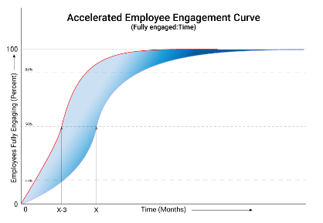
- Shape-shift the Engagement Curve.
Statistics show that out of 1,000 people, 10-15% (group 1) will need little encouragement and will adapt quickly. Another 70-80% (group 2) change slowly and will need a good level of encouragement. The remaining 10-15% (group 3) will resist until they can resist no more. The task is to affect 20-25% of Group 2, bringing them forward in the timeline by a few months. This creates a momentum for the rest of Group 2.
Once Group 3 determines that they are outside the norm then they too will engage. Shifting the Engagement Curve will shift the overall performance and organizational results. The financial impact of preventing a 3-month delay - or better yet being 2 months early - can represent $3-5 million on some projects. Ask yourself this question, “How much would I invest to get a $3 million return?”

A number of other, subtle adjustments can be done to create a significant difference but these 3 are a great start towards reducing risks in a Digital Transformation initiative. You can apply these innovations to existing, struggling projects or integrate them into future initiatives.

